# Citizen Oversight Committee Bio: Eric Mannes, Real Estate/Alternate

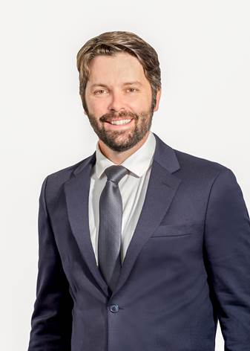

Eric is a realtor in the town he has lived in his whole life. The son of a veterinarian and a former board member of the Brevard Zoo, Eric has a vast appreciation for the natural beauty of the area as a result, and grew up in and around the lagoon and has seen its decline over his lifetime. From stocking an aquarium with lagoon fish to fishing, spearfishing and crabbing, Eric has found just about every way to enjoy the lagoon and has a profound interest in seeing it return to its former glory, both for himself and his clients, as he knows the amazing lifestyle opportunities that this once majestic body of water has to offer.