Cruickshank Scrub Sanctuary Trail Map
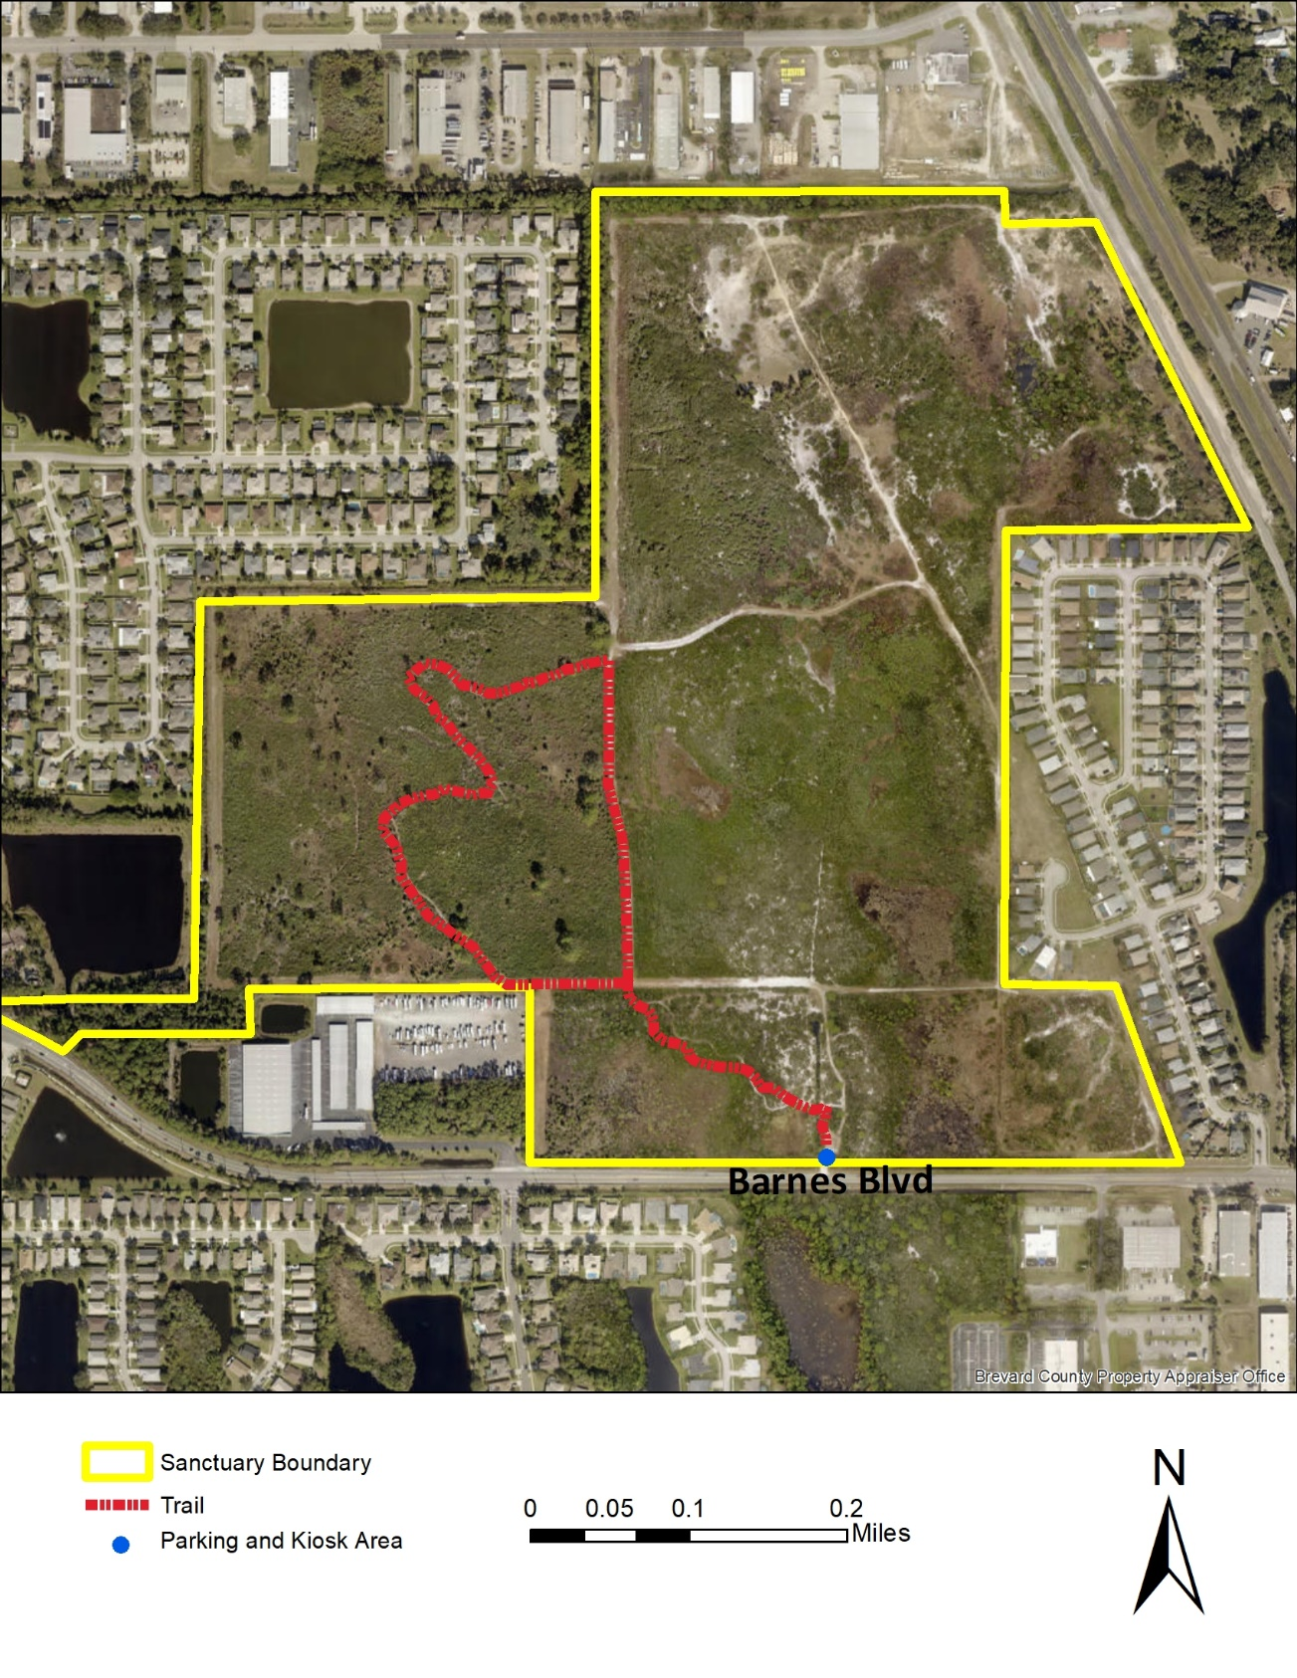
Cruickshank Scrub Sanctuary trail map long description

Cruickshank Scrub Sanctuary Trail Map
This aerial view of Cruickshank Scrub Sanctuary displays the locations of the site boundary and hiking trail. This property is part of the Brevard County Florida Environmentally Endangered Lands Program. These features are overlaid on a 2021 aerial image photograph. The site is bordered by neighborhoods on the east and west boundaries with an industrial zoned area to the north with a variety of businesses. Barnes Boulevard runs east and west along the southern property boundary.
The hiking trail represented is approximately 1 mile in the southwest portion of the site.
A parking area and kiosk is represented at southern boundary of Cruickshank Scrub Sanctuary at Barnes Boulevard.

Cruickshank Scrub Sanctuary Coin Hunt Photo 1
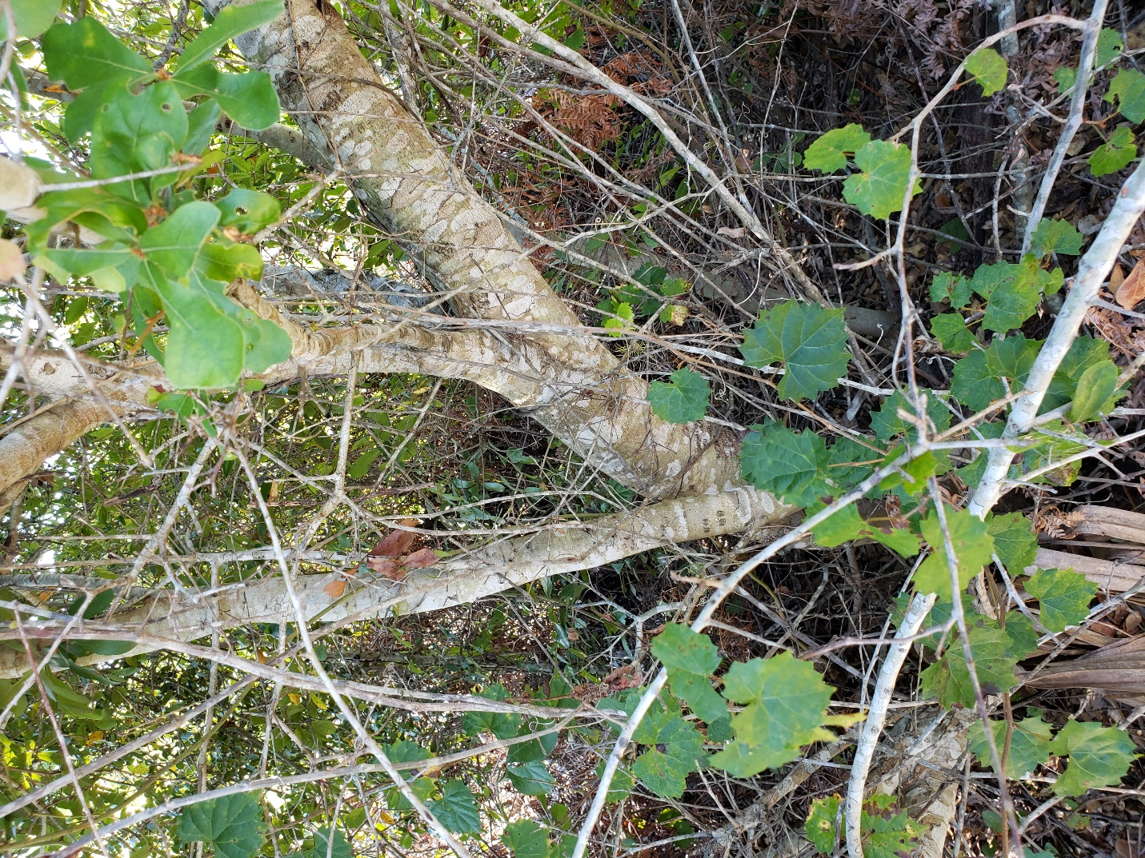
Figure 1: A small tree and vines viewed from a trail.

Cruickshank Scrub Sanctuary Coin Hunt Photo 2
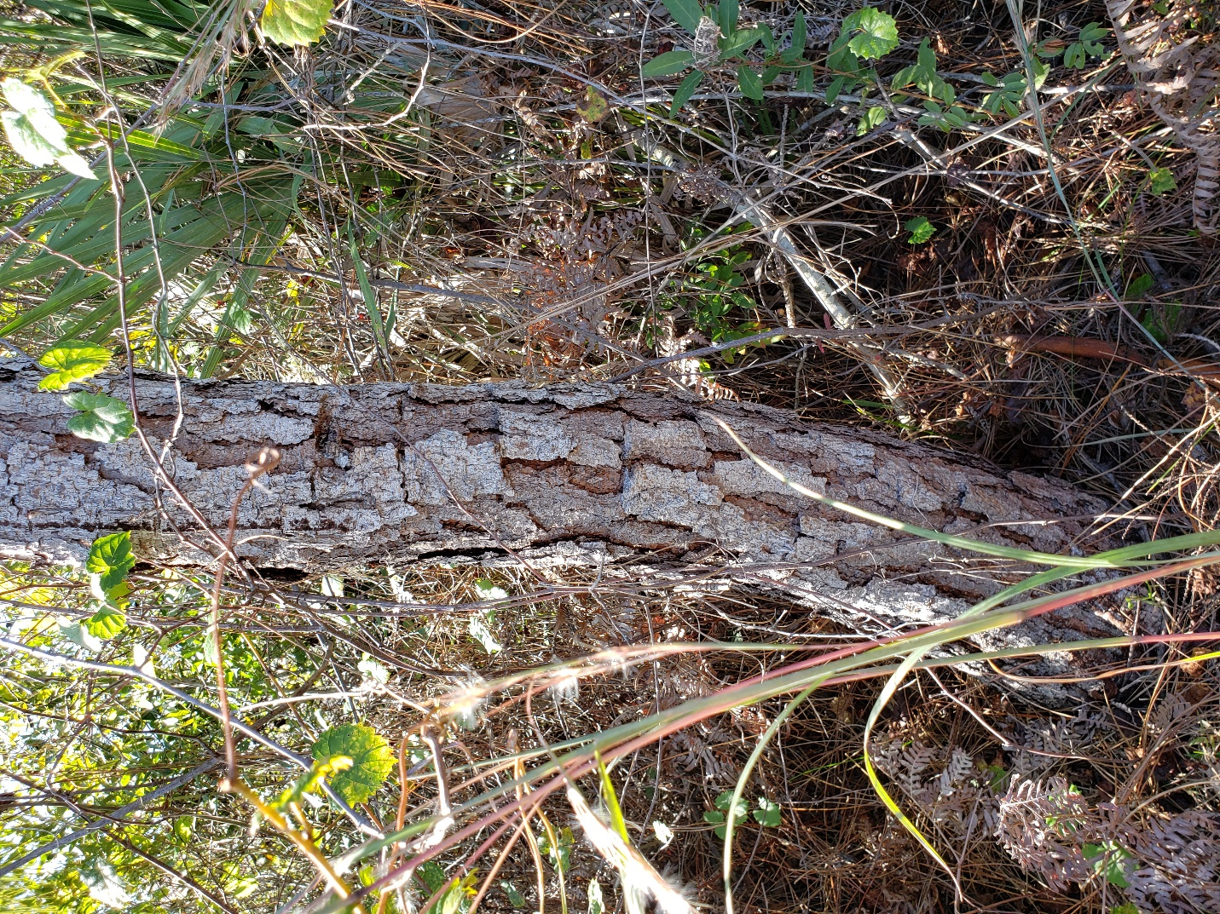
Figure 2: A tree, tall grass and ferns viewed from a trail.

Cruickshank Scrub Sanctuary Coin Hunt Photo 3
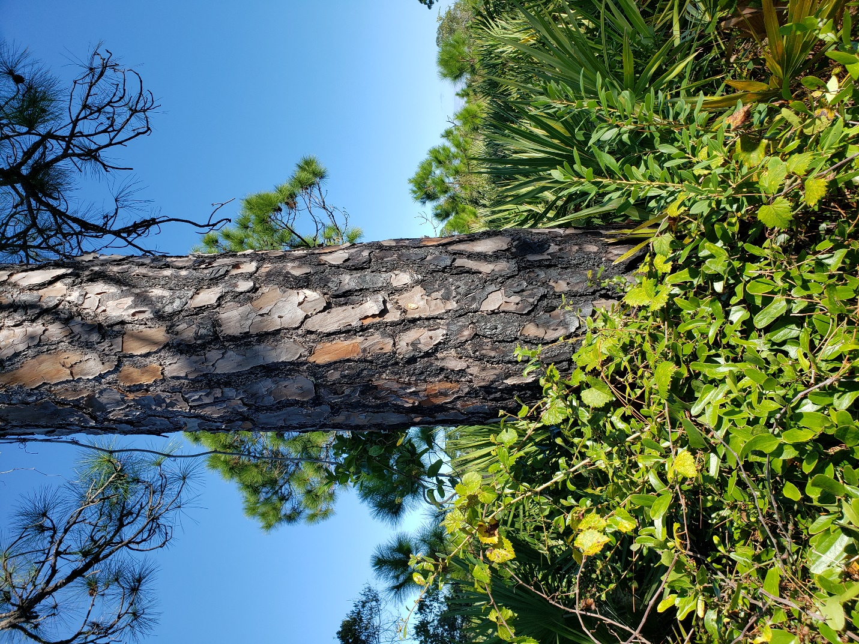
Figure 3: A large tree and vines viewed from a trail.

Cruickshank Scrub Sanctuary Coin Hunt Photo 4
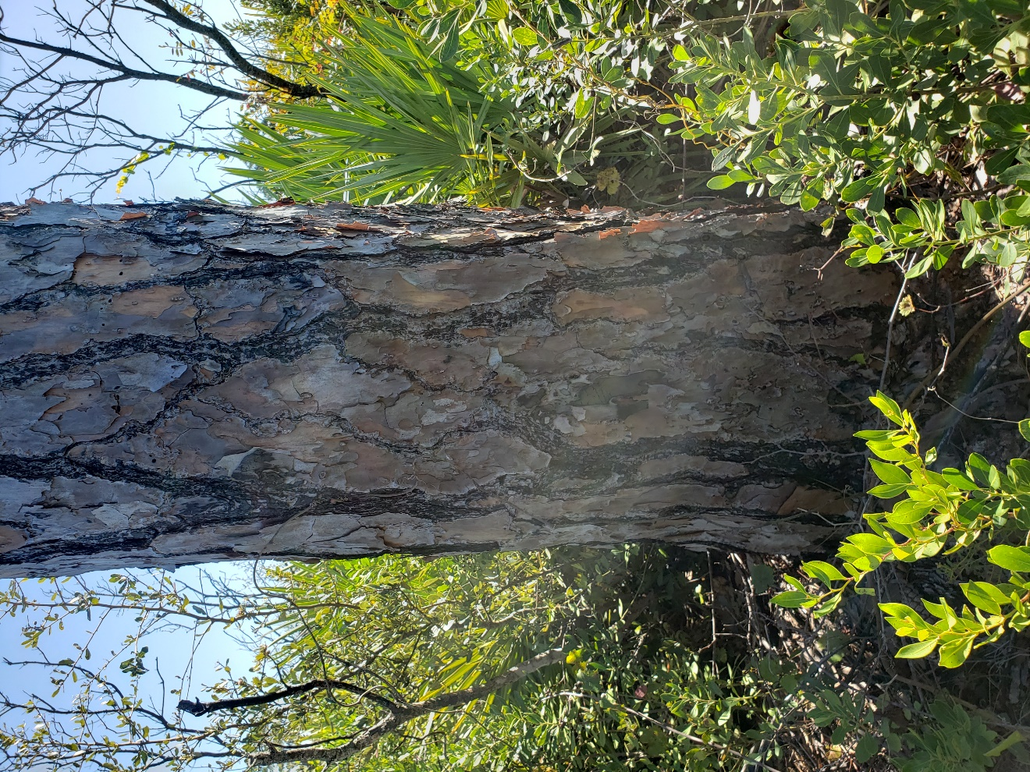
Figure 4: A large tree, palmettos and shrubs viewed from a trail.

Cruickshank Scrub Sanctuary Coin Hunt Photo 5
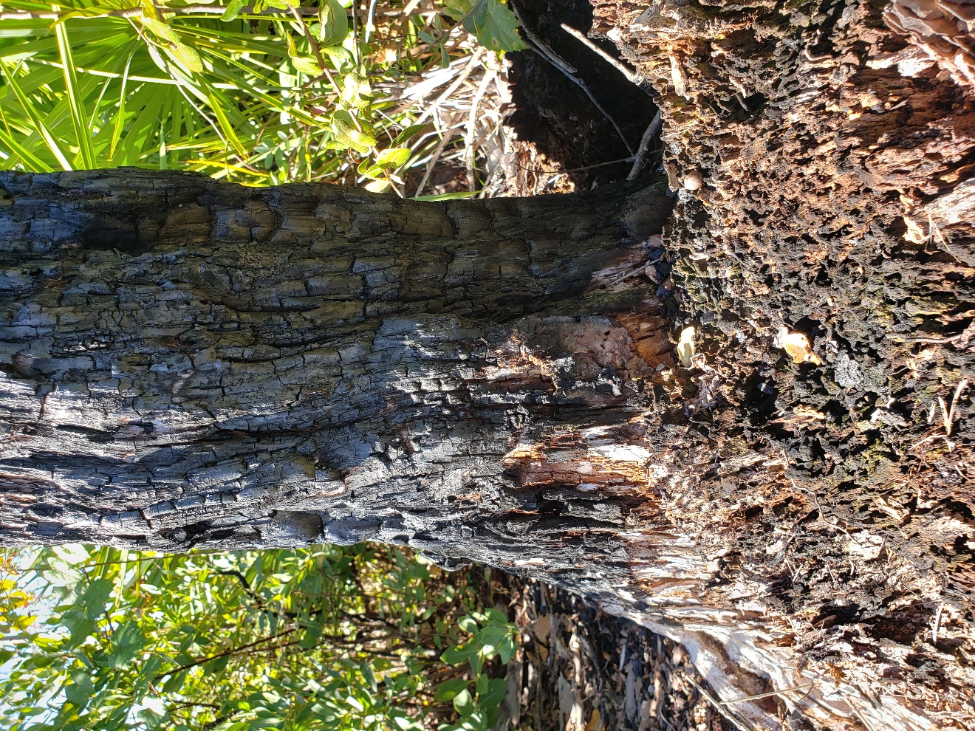
Figure 5: Image of burned tree viewed from a trail.

Cruickshank Scrub Sanctuary Coin Hunt Photo 6
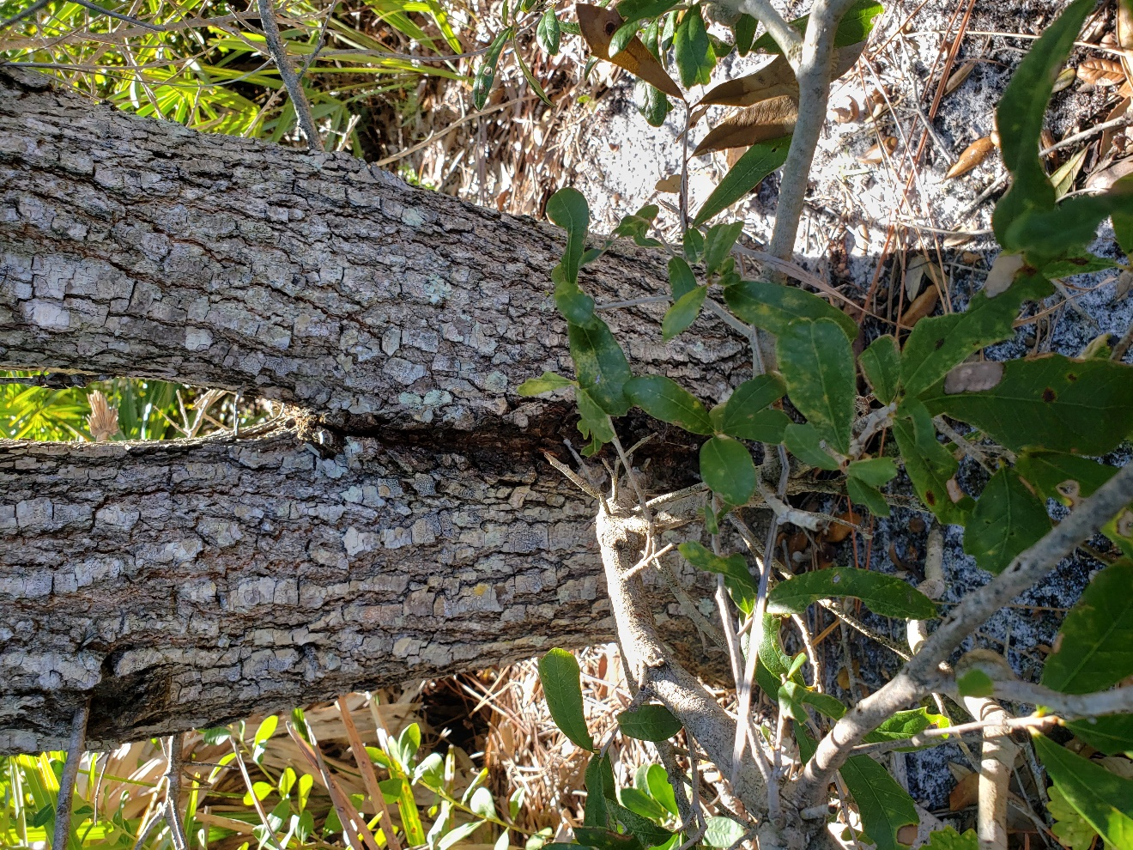
Figure 6: Image of a forked tree viewed from a trail.

Cruickshank Scrub Sanctuary Coin Hunt Photo 7
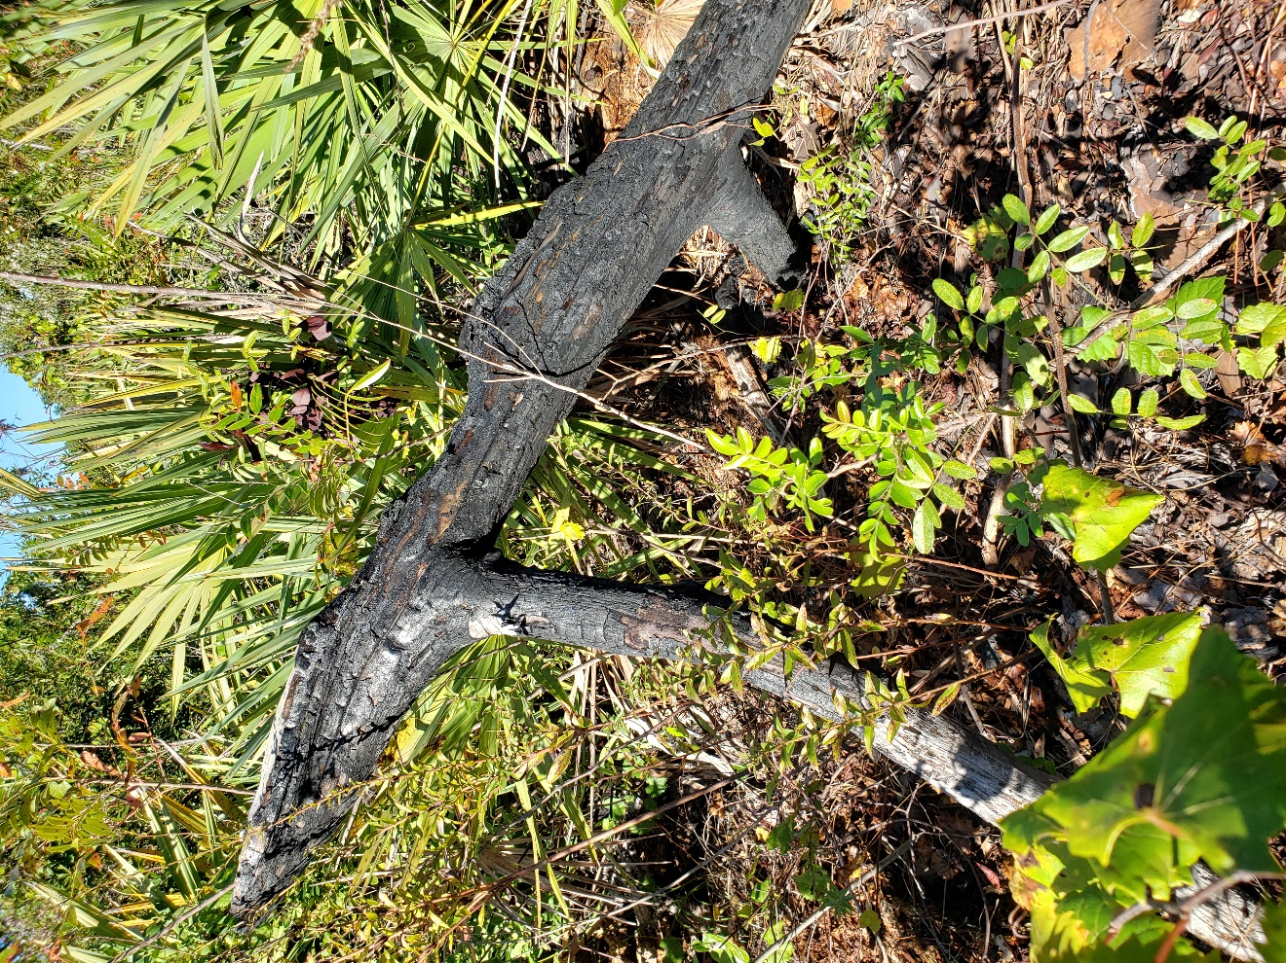
Figure 7: Image of a burned tree branch viewed from a trail.

Cruickshank Scrub Sanctuary Coin Hunt Photo 8
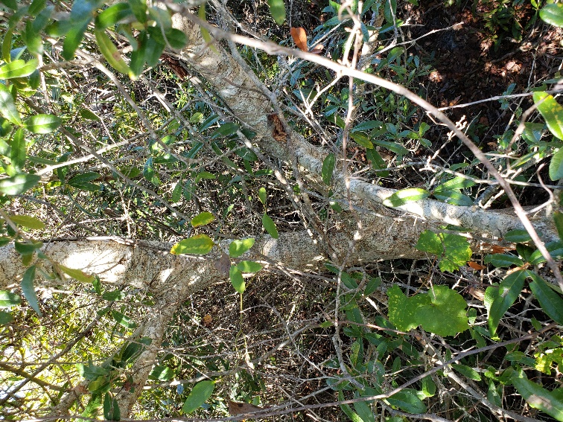
Figure 8: Image of a small tree and vines viewed from a trail.

