Citizen Oversight Committee Bio: Laurilee Thompson, Tourism/Alternate
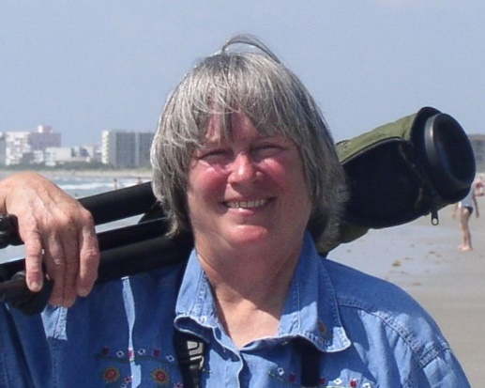
Laurilee is a fifth generation Floridian and lifelong Brevard County resident with an unshakable commitment to the natural resources of Central Florida, including the Indian River Lagoon. She is the co-owner of Dixie Crossroads, a southern seafood restaurant in Titusville, FL with international name recognition and a menu that features locally caught seafood. An avid naturalist with a pragmatic eye to the sustainable use of natural resources, Laurilee is an important advocate for the promotion, protection, and responsible use of our natural resources. She is the founder and driving force behind the highly successful Space Coast Birding and Wildlife Festival, one of the nation’s top events of its type.
She is a board member of the following organizations: Florida Restaurant and Lodging Association, Brevard County Tourist Development Council, Brevard Indian River Lagoon Coalition, Merritt Island Wildlife Association and Brevard Nature Alliance, and a member of the Brevard County Environmentally Endangered Lands Selection and Management Committee, the Deepwater Shrimp Advisory Panel for the South Atlantic Fisheries Management Council and the Indian River Lagoon Council Management Board. She is a recognized constituent in both Tallahassee and Washington, DC where she is a regular proponent for the tourism industry and the U.S. commercial fishing industry.

