Lorraine Koss, Chair, Science/Member
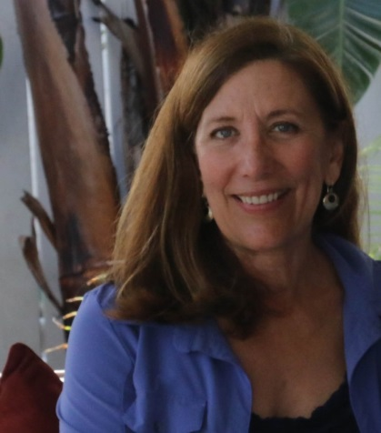
Lorraine Koss’ career has been in national water policy. Formerly, she served as Deputy Director of the U.S. Water Alliance, a Washington D.C. non-profit. She was also with the Water Environment Federation for 18 years prior. Lorraine has been active on Lagoon issues through the Marine Resources Council, and serves on the Board of the League of Women Voters where she’s organized the FLSUN (Solar United Neighborhoods) co-op project. Her Master’s Degree is in Environmental Management from Duke University. Lorraine lives in Cocoa with her husband, a Brevard County native. She has two sons, enjoys sailing, gardening, and playing tennis.

